

Year 11 Integrated Science

Unit 1 Semester 1 2023

**Cells and Body Systems Test**

Student Name: ______________________________

Assessment Date:

**TOTAL MARKS**

**/40**

Working time: 50 minutes

Weighting: 5%

Teacher Comments:

**You should answer ALL of the questions and show full working.**

**Must be completed under test conditions.**

**SECTION A: MULTIPLE CHOICE**

1. What is a cell?
   1. A small, non-living unit of a living thing
   2. The basic building block of all living things
   3. A large mass of tissue
   4. The basic building block of all matter
2. Which one of these statements about cell theory is correct?
   1. All living things are made of cells that are formed from other cells.
   2. Organelles are the basic structure of all things.
   3. All living things are made of a single giant cell that contains all the components for life.
   4. Cells can spontaneously form from non-living material.
3. Which option shows the levels of organisation from least complex to most complex?
   1. tissue 🡪 organism 🡪 organ 🡪 cell 🡪 organ system
   2. organism 🡪 organ 🡪 organ system 🡪 tissue 🡪 cell
   3. cell 🡪 tissue 🡪 organ 🡪 organ system 🡪 organism
   4. cell 🡪 tissue 🡪 organ system 🡪 organism 🡪 organ

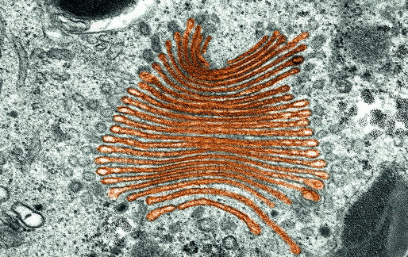

1. Which organelle is shown in the picture to the right?
   1. nucleus
   2. chloroplast
   3. Golgi body
   4. vacuole
2. The cytoplasm is:
   1. The gel-like substance within the cell where cell processes take place.
   2. The energy source of a cell where cell respiration occurs.
   3. The rigid structure on the outside of plant cells.
   4. A small organelle that contains enzymes to break down waste material.
3. Which organelle is responsible for photosynthesis in plant cells?
   1. mitochondria
   2. chloroplast
   3. nucleus
   4. endoplasmic reticulum

**SECTION B: SHORT RESPONSE**

**Question 7**

List three differences between plant and animal cells. (3 marks)

1.

2.

3.

**Question 8**

Describe the function of the following organelles found in cells: (3 marks)

Nucleus:

Mitochondria:

Cell membrane:

**Question 9**

Label the features of the cell below. (5 marks)

**1**

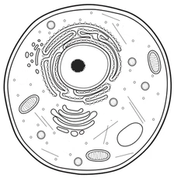 1.

**2**

2.

3.

4.

**3**

5.

**5**

**4**

**Question 10**

Blood is a tissue in the human body that performs the function of transporting oxygen, providing immune defence and blood clotting. It consists of a range of cells such as red blood cells (which carry oxygen), white blood cells (which are part of the immune system), and platelets (which play a role in blood clotting).

Using blood as an example, explain the difference between a tissue and a group of unrelated cells.

(3 marks)

**Question 11**

Describe the difference between an organ and an organ system and give an example of each.

(3 marks)

**Question 12**

Describe the function of the following organ systems in the human body: (3 marks)

Digestive System:

Respiratory System:

Circulatory System:

**Question 13**

A human sperm cell is a small cell whose role in the reproductive system is to reach and fertilise an egg cell. Explain how a sperm cell is well adapted to its function. (4 marks)



mitochondria

flagellum

**Question 14**

The cells in the root of an onion plant do not have chloroplasts but the cells in its leaves do. Using your knowledge of organelles, explain why. (2 marks)

**Question 15**

Choose an organ system in the human body and describe it in detail. (9 marks)

Include information on:

* its function
* A picture containing linedrawing, silhouette

  Description automatically generatedhow it achieves its function through specific organs
* how it is adapted well to perform its function
* other organ systems that it communicates with
* a labelled diagram of the major organs

_______________________________________________________________________________________

_______________________________________________________________________________________

_______________________________________________________________________________________

_______________________________________________________________________________________

_______________________________________________________________________________________

_______________________________________________________________________________________

_______________________________________________________________________________________

_______________________________________________________________________________________

_______________________________________________________________________________________

_______________________________________________________________________________________

_______________________________________________________________________________________

_______________________________________________________________________________________

_______________________________________________________________________________________

_______________________________________________________________________________________

_______________________________________________________________________________________

_______________________________________________________________________________________

_______________________________________________________________________________________

_______________________________________________________________________________________

_______________________________________________________________________________________

_______________________________________________________________________________________

_______________________________________________________________________________________

_______________________________________________________________________________________

_______________________________________________________________________________________

_______________________________________________________________________________________

_______________________________________________________________________________________